Olist E-Commerce Data Project
Summary Report for Stakeholders
Prepared from Olist's order, product, payment, and customer review records

Executive Summary
We consolidated Olist's order, product, payment, customer, seller, and review records originally spread across 9 separate files into a single, unified dataset covering every item sold. Along the way, we reviewed the data for accuracy and completeness, and identified several findings that are directly relevant to operations and customer experience.
This report summarizes those findings in plain terms. A separate, more technical document is available for the data/engineering team covering exactly how the data was processed.

112,650  items sold, now fully tracked in one place | 99,441  customer orders analyzed | 32,951  unique products reviewed

Finding 1 — A Small but Real Gap in Delivery Tracking
Nearly 3,000 orders (about 3% of all orders) have no confirmed delivery date on file. The chart below breaks down why:
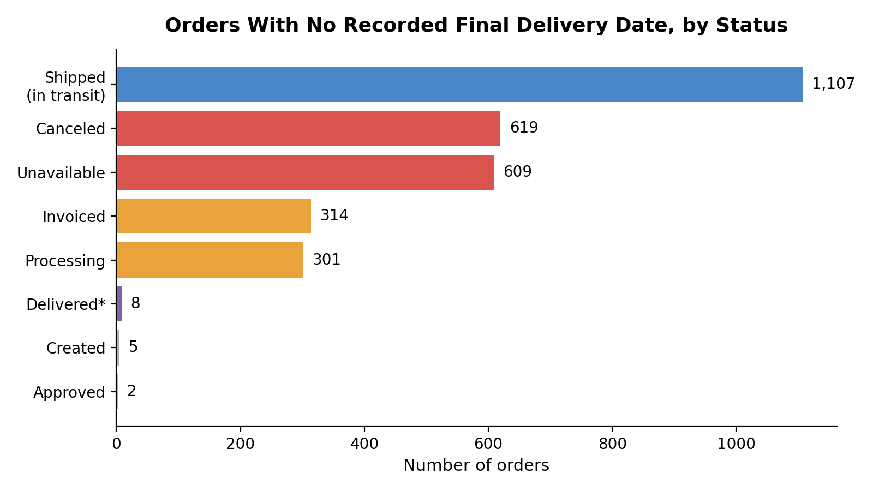
Most of this is expected and not a concern these are orders still shipping, cancelled, or otherwise not yet complete. However, 8 orders are marked as “delivered” in the system with no delivery date ever recorded a small tracking gap worth mentioning to the fulfillment/logistics team, since it means a handful of “successful” deliveries currently can't be timestamped or verified.
Business takeaway: Delivery tracking is reliable for 97%+ of orders. The remaining gap is small (0.03% of all orders) but represents a blind spot in verifying that certain deliveries actually happened on time.

Finding 2 — One Order Needs Follow-Up
While reviewing the data, we found one specific order that stands out: it's marked as “delivered”, has no payment recorded at all, and the customer left a 1-star review stating they never received the product and never got a response from the company.
This combination delivered on paper, unpaid, and a formal complaint doesn't fit the normal pattern of a cancelled or in-progress order. We recommend this order be manually reviewed by customer service or operations, since it may indicate a customer service failure, a fraud case, or a data entry error.

Finding 3 — Product Catalog Has Some Incomplete Listings
610 products (about 2% of the catalog) are missing basic listing information no category, no description length, no photo count on file. These products were still sold, so this isn't blocking sales, but it does limit our ability to analyze what categories are driving revenue, or to recommend similar products to customers, for this slice of the catalog.
Separately, and unrelated to the above, 2 individual products are missing shipping weight/size information a very minor gap, but worth flagging for the catalog team since it could affect shipping cost estimates for those specific items.

Finding 4 — Customers Often Split Payments, Sometimes Heavily
It's common for customers to pay using more than one method or transaction per order installment plans, vouchers, or gift credits are a normal part of the buying pattern in this market. In one notable case, a single customer applied 29 separate voucher payments to complete one order.
Business takeaway: This is a normal and expected shopping behavior in this market, not a system error. It's worth knowing about because it affects how “revenue per order” should be calculated and reported a simple one-row-per-order assumption would understate how payments actually work.

Finding 5 — Most Orders Are Reviewed Once, But Not Always
551 orders received more than one review submission from the customer in the cases we examined, this reflects follow-up prompts (the customer was asked again later), not duplicate or erroneous data. Where this happened, we used the customer's most recent review as the representative one for that order.

Data Reliability
Before combining the 9 source files into one, each was checked individually for missing values, duplicate records, and formatting issues (for example, postal codes that had lost leading zeros, and dates stored as plain text instead of usable dates). Every issue found was investigated and resolved deliberately nothing was assumed or silently dropped.
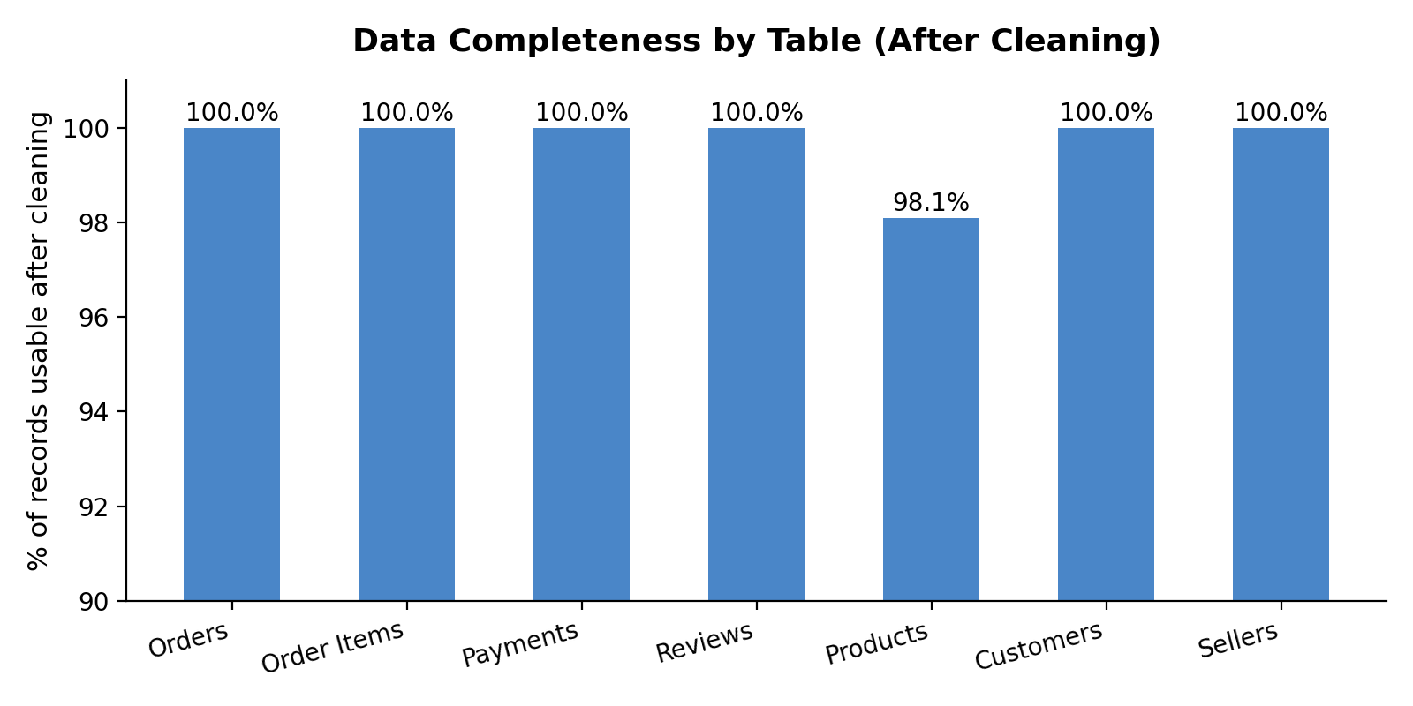
The chart above shows the percentage of usable records in each core data source after cleaning. Every table is 98% or more complete; the only meaningful gap is the 610 incomplete product listings discussed in Finding 3.
Data integrity check: When the 9 tables were combined into the final dataset, we verified no records were accidentally duplicated or lost in the process the final item count matches exactly what we started with (112,650 items, before and after combining).

Recommendations
- Investigate the single flagged order (Finding 2) as a priority it has the hallmarks of a customer service failure that may need direct outreach or a refund review.
- Share the delivery-tracking gap (Finding 1) with the logistics/fulfillment team while small, closing it would improve confidence in delivery-time reporting.
- Treat the 610 incomplete product listings (Finding 3) as a catalog clean-up opportunity completing this metadata would unlock better category-level sales reporting.
- When reporting on “revenue per order” or “average payment,” account for multi-payment orders (Finding 4) rather than assuming one payment per order.

Next Steps
The unified dataset is ready to support reporting and analysis for example, sales by category, delivery performance, customer satisfaction trends, and seller performance. A technical appendix is available on request, documenting exactly how each data source was cleaned and combined, for teams that need that level of detail.

